Name: SAJALI GHOSH
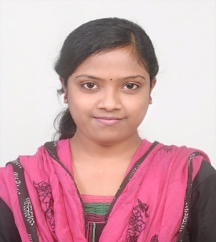
Contact No.: 7205702235, 9439844182
Email id :sajali.ghosh91@gmail.com
PROFILE

A challenging, determined commerce student with good communication skills and ready to work both independently and as a member of a team, utilizing the skills acquired during my course and experience.
carrior objectives
Obtain a position as a team-player in a people-oriented organization where I can maximize my skills and knowledge in a challenging environment to achieve the corporate goals.
PERSONAL TRAITS

- Dynamic & Smart working.
- Self Motivation and Good in Team Work.
- Good in Inter personal relationship and communication

Scholastic Profile
Year of pass | Degree | Institute | Specialization | % of Mark
Continuing | MPHIL | G.M Autonomous college | -- | --
2014 | M.COM | Fakir Mohan University | Finance | 65%
2012 | B.COM | Fakir Mohan(Auto) college. | Accounting and Finance | 65.7%
2009 | 10+2 COM. | Council of Higher Secondary Education, Orissa | Commerce | 71%
2007 | 10th | Board of Secondary Education, Orissa | Oriya | 79%

IT Credentials
Program or Course | Module
ERP APPLICATION | Tally ERP 9.0
OPERATING SYSTEM & COMPUTER LITERACY | *DOS, Windows 2000/XP/Win7  * MS OFFICE Package & Internet.  *PGDCA

Personal Details
Permanent Address | Bateswar,Motiganj, Balasore, | Date Of Birth | 2nd Jan 1992
Pin | 756003 | Sex | Female
Language Known | Bengali,Oriya, English, Hindi | Marital Status | Single

Declaration
I hereby declare that all the above information furnished is true to the best of my knowledge and belief.

Date: - 23th march2016 SajaliGhosh
Place: - Balasore Signature

